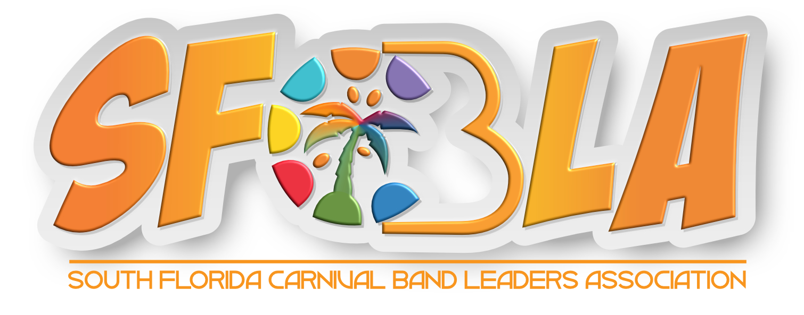

Agreement for Assumption of Risk, Indemnification, and Release, for Band Participants

Event: ____________________ (the “Event”) Printed Name of Participant: ____________________

Band: _______________________________________ (the “Band”)

In consideration of the Band’s consent to allow me to participate in any or all recreational or other activities related to South Florida Carnival Band Leaders Association, Inc. (including without limitation, Miami Carnival Showcase, Modeling Events, festivities), I hereby knowingly, freely and voluntarily agree to waive, release and discharge any and all claims for damages for death, personal injury, or property damage that may have, or that may subsequently accrue to me as a result of my participation in recreational or other activities offered, afforded, or sponsored by the Band.

Assumption of Risk: I understand that the South Florida Carnival Band Leaders Association, Inc., by its very nature, includes certain inherent risks that cannot be eliminated regardless of the care taken to avoid injuries. The specific risks vary, and may range from: 1) minor injuries such as scratches, bruises, sprains, and the like, to 2) major injuries such as loss of hearing, eye injuries, loss of vision, loss of limb, joint or back injury, heart attack, and concussions, to 3) catastrophic injuries including death. I understand and appreciate that these and other risks are inherent in the above-listed events and activities. I hereby assert that my participation is voluntary and that I knowingly assume all such risks. I further understand that I am ultimately responsible for my own safety.

Hold Harmless and Indemnification: I agree, for myself, my heirs, personal representatives or assigns, to defend, hold harmless, and indemnify, the South Florida Carnival Band Leaders Association, the Band, its officers, directors, employees, agents, volunteers, and affiliates, from and against any and all claims, demands, actions, suits, procedures, causes of action, damages, costs (including reasonable attorneys fees) and expenses that may result from or is in any way related to my participation in the South Florida Carnival Band Leaders Association, Inc. This indemnity includes claims based on the negligence (whether sole, active, passive, or gross) of the Band, its officers, employees, agents, affiliates, and volunteers, but expressly does not include claims based on their intentional misconduct.
Release and Waiver: I hereby release, waive, and covenant, not to sue the South Florida Carnival Band Leaders Association, the Band, its officers, directors, employees, agents, volunteers, and affiliates, from and for any and all claims and/or liability resulting from any personal injury, accident or illness (including death), and/or property damage or loss, however caused by, arising from, or in any way related to, my participation in the Miami Carnival Showcase. This release includes claims based on the negligence (whether sole, active, passive, or gross) of the SFCBLA, the Band, its officers, employees, agents, affiliates, and volunteers. I understand that by agreeing to this clause I am releasing claims and giving up substantial rights, including my right to sue.
Conduct: I agree to follow all instructions, procedures, measures and directions given to me by the Band or any of its staff or representatives and understand that my failure to do so may result in property damage or injury or death to me or to a third party. I understand that my invitation to participate in recreational or other activities on the Properties may be revoked at any time for any reason by the Band or any of its agents, managers, employees or representatives.
Permission to Use Likeness/Name: The undersigned further agree to allow, without compensation, Participant’s likeness and/or name to appear, and to otherwise be used, in material, regardless of media form, promoting the South Florida Carnival Band Leaders Association, the Miami Carnival Showcase or the Band, and/or its, events and activities, including those of its representatives, assigns, and licensees.
Severability: I understand that the foregoing waiver and assumption of risks agreement is intended to be as broad and inclusive as is permitted by the law of the State of Florida and that if any portion thereof is held invalid, it is agreed that the balance shall, notwithstanding, continue in full legal force and effect and be binding on myself, my spouse, my heirs and personal representatives.

I UNDERSTAND THAT THIS WAIVER, RELEASE AND INDEMINTY IS INTENDED TO WAIVE, RELEASE, DISCHARGE AND INDEMINIFY IN ADVANCE THE BAND AND ITS AFFLIATES, SUBSIDIARIES, MEMBERS, MANAGERS, OFFICERS, EMPLOYEES, INSURERS, AGENTS, REPRESENTATIVES, SUCCESSORS AND ASSIGNS, FOR, FROM AND AGAINST ANY AND ALL LIABILITY TO ME ARISING FROM MY PARTICIPATION IN ANY AND ALL RECREATIONAL OR OTHER ACTIVITIES DURING OR ASSOCIATED WITH SOUTH FLORIDA CARNIVAL BAND LEADERS ASSOCIATION, INC, INCLUDING ANY DEMAND, RIGHT OR CAUSE OF ACTION OF ANY KIND OR NATURE WHATSOEVER, WHETHER BASED ON TORT (INCLUDING NEGLIGENCE ON THE PART OF THE BAND), CONTRACT, WARRANTY, OR ANY OTHER THEORY OF RECOVERY, AT LAW OR INEQUITY, VESTED OR CONTINGENT, THAT I OR MY SPOUSE, FAMILY, PARENTS, CHILDREN, ESTATE, HEIRS, AGENTS, INSURERS, SUCCESSORS OR ASSIGNS MAY AT ANY TIME HAVE AS A RESULT OF MY PARTICIPATION IN RECREATIONAL OR OTHER ACTIVITIES DURING OR ASSOCIATED WITH SOUTH FLORIDA CARNIVAL BAND LEADERS ASSOCIATION, INC. THIS ALSO INCLUDES, WITHOUT LIMITATION, ANY LIABILITY (INCLUDING CONSEQUENTIAL, INDIRECT, SPECIAL OR INCIDENTAL DAMAGES) ARISING FROM INJURY OR DAMAGE THAT I SUFFER OR CAUSE DURING MY PARTICIPATION IN RECREATIONAL OR OTHER ACTIVITES DURING OR ASSOCIATED WITH SOUTH FLORIDA CARNIVAL BAND LEADERS ASSOCIATION, INC, WHETHER SUCH INJURY OR DAMAGE IS FORESEEN OR UNFORESEEN OR WHETHER RESULTING FROM NEGLIGENCE OR OTHERWISE.

____________________________________
Signature of Participant

____________________________________
Signature of Parent/Guardian of Participant if Minor

